ASSIGNMENT 7
POSTFIX TO PREFIX
CODE :
#include <stdio.h>
#include <string.h>
#include <ctype.h>

#define MAX 100

char stack[MAX][MAX];
int top = -1;

void push(char str[]) {
strcpy(stack[++top], str);
}

char* pop() {
return stack[top--];
}

int main() {
char postfix[MAX];
char op1[MAX], op2[MAX], temp[MAX];
int i;

printf("Enter postfix expression: ");
scanf("%s", postfix);

for (i = 0; postfix[i] != '\0'; i++) {

if (isalnum(postfix[i])) {
char operand[2];
operand[0] = postfix[i];
operand[1] = '\0';

push(operand);
}

else {
strcpy(op2, pop());
strcpy(op1, pop());

sprintf(temp, "%c%s%s", postfix[i], op1, op2);

push(temp);
}
}

printf("Prefix expression: %s\n", pop());

return 0;
}

OUTPUT :
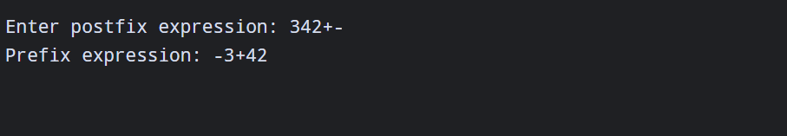

PREFIX TO POSTFIX
CODE :
#include <stdio.h>
#include <string.h>
#include <ctype.h>

#define MAX 100

char stack[MAX][MAX];
int top = -1;

void push(char str[]) {
top++;
strcpy(stack[top], str);
}

void pop(char str[]) {
strcpy(str, stack[top]);
top--;
}

int main() {
char prefix[MAX];
char op1[MAX], op2[MAX], temp[MAX];

printf("Enter prefix expression: ");
scanf("%s", prefix);

for (int i = strlen(prefix) - 1; i >= 0; i--) {

if (isalnum(prefix[i])) {
char operand[2];
operand[0] = prefix[i];
operand[1] = '\0';

push(operand);
}
else {
pop(op1);
pop(op2);

strcpy(temp, op1);
strcat(temp, op2);

int len = strlen(temp);
temp[len] = prefix[i];
temp[len + 1] = '\0';

push(temp);
}
}

printf("Postfix expression: %s\n", stack[top]);

return 0;
}

OUTPUT :
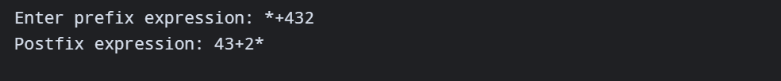

INFIX TO POSTFIX
CODE :
#include <stdio.h>
#include <ctype.h>
#include <string.h>

#define MAX 100

char stk[MAX];
int top = -1;

void push(char c) { stk[++top] = c; }
char pop(void) { return stk[top--]; }

int isp(char c) {
switch (c) {
case '(': return 0;
case '+':
case '-': return 2;
case '*':
case '/':
case '%': return 4;
case '^': return 5;
}
return -1;
}

int icp(char c) {
switch (c) {
case '(': return 7;
case '+':
case '-': return 1;
case '*':
case '/':
case '%': return 3;
case '^': return 6;
}
return -1;
}

void in_post(char inexp[], char postexp[]) {
int k = 0, i = 0;
char tkn = inexp[i];

while (tkn != '\0') {
if (isalnum(tkn)) {
postexp[k++] = inexp[i];
}
else if (tkn == '(') {
push('(');
}
else if (tkn == ')') {
while ((tkn = pop()) != '(')
postexp[k++] = tkn;
}
else {
while (top != -1 && isp(stk[top]) >= icp(tkn))
postexp[k++] = pop();
push(tkn);
}

i++;
tkn = inexp[i];
}

while (top != -1)
postexp[k++] = pop();

postexp[k] = '\0';
}

int main(void) {
char inexp[MAX], postexp[MAX];

printf("Enter infix expression (no spaces): ");
scanf("%s", inexp);

in_post(inexp, postexp);

printf("Postfix expression: %s\n", postexp);
return 0;
}

OUTPUT :
